
SUNSHINE AWARD
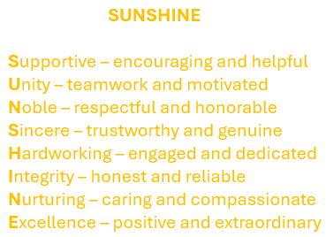
The SUNSHINE Award is given to an outstanding nursing assistant who consistently demonstrates high quality care and compassion for every patient they see and every coworker they support. This person goes above and beyond to help and always strives to
do their very best.

To nominate a PVH Nursing Assistant, fill out and submit the form below:
I would like to nominate ____________________________________________ from the _______________________________ department for the SUNSHINE AWARD.
Date of nomination _______________
Your name ___________________________________ Phone ____________________
Email ____________________________
I am a (check one): patient family/visitor volunteer staff member

Please provide your reason for nominating the person on the back of this form.
When complete, please submit to:
Candice Metcalf, Director of Nursing
Potomac Valley Hospital
100 Pin Oak Lane, Keyser, WV 26726
Email: candice.metcalf@wvumedicine.org

Phone: 304-597-3663

