

Sunrise Acute Care 5.5:
Order Entry

End-User Training Guide

Camden Clark Medical Center
Parkersburg, WV
Table of Contents

Table of Contents 2
Course Goals/Objectives 3
1: Allergy Review at Order Entry 4
2: Basic Order Entry 7
Order Session Types 9
STOP HERE FOR THE END OF BASIC ORDER ENTRY! 24
+++++++++++++++++++++++++++++++++++++++++++++++++++++++++++++ 24
3: Advanced Order Entry 25
37
4: Order Review 38
5: Order Maintenance 44
55
5.Click Send New Message on the right side of the screen. 56
56
This icon appears when you have sent a message to pharmacy. 56
This icon appears when pharmacy has read the request. 56
This icon appears when pharmacy has replied to your message. 56
6: Signature Manager 57
Toolbar Buttons Related to Order Entry Functions 64
Icons on the Orders Tab 65

Course Goals/Objectives

At the completion of this course, you will be able to:

- Use the various components of the Order Entry Worksheet
- Demonstrate how to enter orders using the Enter Order button
- Demonstrate how to manage the review of allergies at order entry
- Enter orders on behalf of a patient’s current or other provider
- Use the order browse to find and enter orders
- Generate alert messages and take action on those alerts
- Use the order requisition form
- Hide the order worksheet and recognize when and why this feature might be used
- Review orders using the Orders tab
- Demonstrate how to use the various order management functions
- Use Signature Manager to sign and verify orders for single or multiple patients.

1: Allergy Review at Order Entry

Add Allergy Information

There are multiple methods of reviewing and adding allergy information:

- From the Patient Info tab
- Allergies Summary button on the toolbar
- From the Order Entry Worksheet (we will look at this method during the order entry process)

- Select the Training Patient from the Patient List.
- Click the Allergies Summary button on the toolbar. The Allergies Summary dialog window displays.

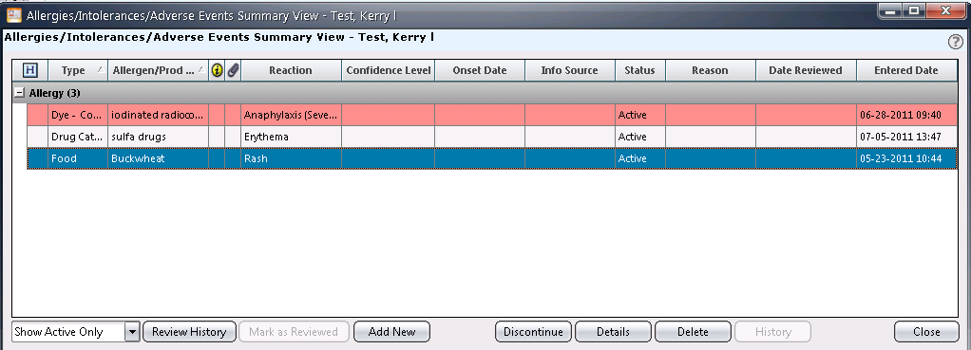

- From this screen, validate any existing allergies as appropriate by clicking on the marked as reviewed button.
- To add a new allergy, click the Add New button. If this is a new patient, the Allergy Type window displays.

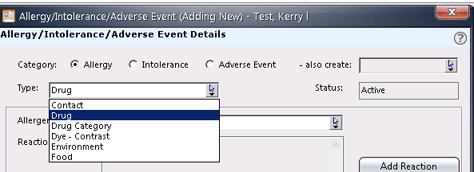

- Select the appropriate allergy type:
  - No Known Allergies – select this option if no allergies exist
  - Allergy Status Unknown – select this option if allergy information is not available or unknown
  - New Allergy – select this option to add new allergy information
- The bold fields are required (Type, Allergen, Reaction); all other fields are optional.
  - Select the type from the Type drop-down list [type].
  - Select the allergen from the Allergen drop-down list [allergen].
  - Click the Add Reaction button. The Reactions Details window displays.
    - If unknown, click the Unknown option.
    - If known, click the select all reactions that apply option and click the checkbox(s) next to the appropriate reaction descriptions [reactions].
    - Click OK.

- Optionally, enter any additional information in the remaining fields.

NOTE: If the allergy being entered requires further detailed descriptive information, use the free-text Description field.

- Click OK.

Modify Allergy Information

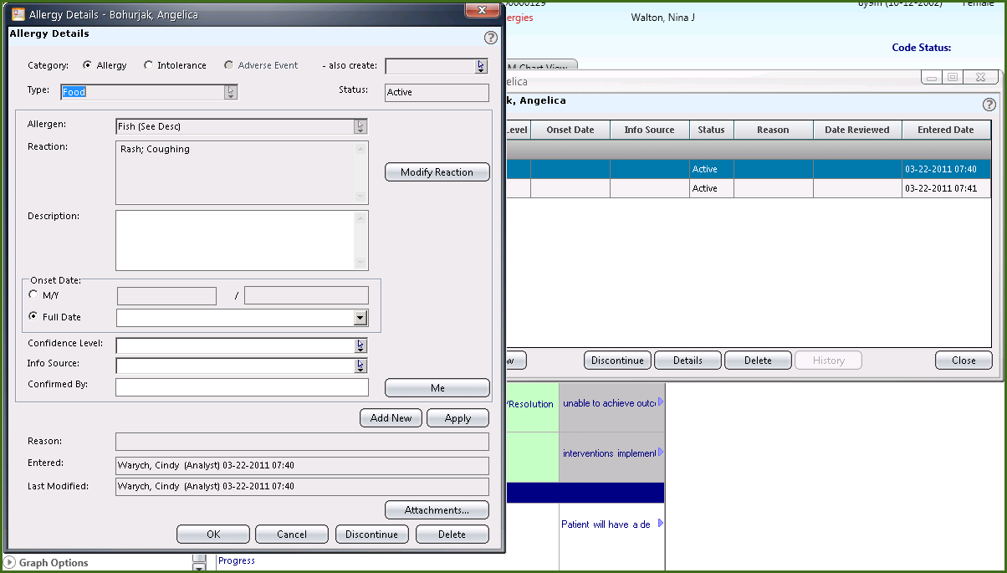

- Select the appropriate patient from the Patient List.

- Click the Allergies Summary button on the toolbar. The Allergies Summary window displays.

- Select the allergy to modify and click the Details button. The Allergy Details window displays.

- Modify the information as appropriate.

NOTE: The Type and Allergen cannot be modified.

- To discontinue the allergy, click the Discontinue button.

- Click OK.

2: Basic Order Entry

All patient orders are entered in a similar fashion on the same Order Entry Worksheet. These orders are electronically communicated to the appropriate ancillary department, and display there as a printout (requisition), screen display or both.

The first step of entering an order, after selecting the appropriate patient, is to access the Order Entry Worksheet.

Accessing the Order Entry Worksheet

- Click the Enter Order button in the Patient Header next to the patient’s name. For non-physician users, the Requested By window displays.

- Select the appropriate Requested By option:

  - Me – select this option to enter orders as yourself

  - Current Providers (default) – select this option to enter orders on behalf of one of the providers displayed who currently have a role in the care of the patient

  - Other – select this option to enter an order on behalf a provider who does not have a current role in the patient’s care. You will need to search for the provider by last name.

- Select the source of the order request from the Source drop-down list.

- Click OK. The Order Entry Worksheet displays. Fields include:

- Allergies - displays current allergies and allows you the ability to add new by clicking the double red arrow at the end of that field.

- Requested By – displays the name of the requesting provider (populates from information entered on the Requested By window)

- Source – if the order is entered on behalf of another, this field displays the source selected on the Requested By window

- Date/Time – can enter a specific date and time of order request or leave blank to accept default of current.

- Session Type – select the order session type from the drop-down list (e.g., Routine, Hold, Pre-op, etc)

- Start of Browse/Manual Entry – to search for an order, type in the order name in the field labeled ‘type here to enter order name’ OR use Order Browse drop-down list to find the order by department.

- Summary Window – displays the order(s) entered before submission; if not correct, you may edit or delete.

Enter a Basic Order - No Required Order Form

- In the “type here to enter order name” field, type CBC.

- Select the CBC order and click Add (or double-click the order)

- If you needed to add additional order instructions and/or modify order details, highlight the order in the Order Summary window and click the Edit button.
The order form opens with the ability to add or modify information.

- Edit the order by changing the Priority from Routine to STAT and click OK.

If you added the order to the Summary window in error, simply highlight the order and click the Delete button.

- Do not submit the order…proceed to the next topic.

Enter a Basic Order – Order Form Required

Enter a basic order, use the manual search field, and order form is required (will auto open with required fields to complete).

- In the order search field, type: XR Chest 1 View

The blue grid icon next to the order name indicates the order form will auto open as information may be required.

- Double-click the Chest Xray order.

Required fields denoted by a red asterisk .

- Complete the required fields:

- Click OK.

- Do not submit the order…proceed to the next topic.

Order Session Types

There are different order session types included in the system. When you place an order, the default order session type is Standard. The other sessions types include this list below:

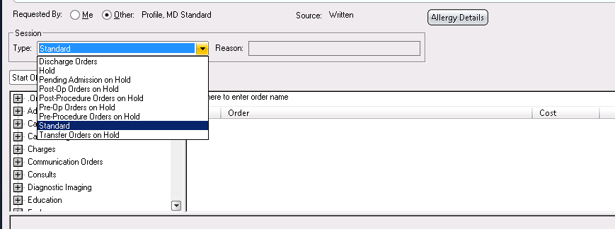

Selecting one of the Hold order sessions allows you to enter order prior to the patient needing them active. For instance, if the patient is in ER but you have already spoken to the admitting physician, you can enter order to be activated once the patient is on the unit. By selecting Pending Admission on Hold you can enter all your order and then release them once the patient has arrived.

All Hold session orders display with the icon and name as seen below:

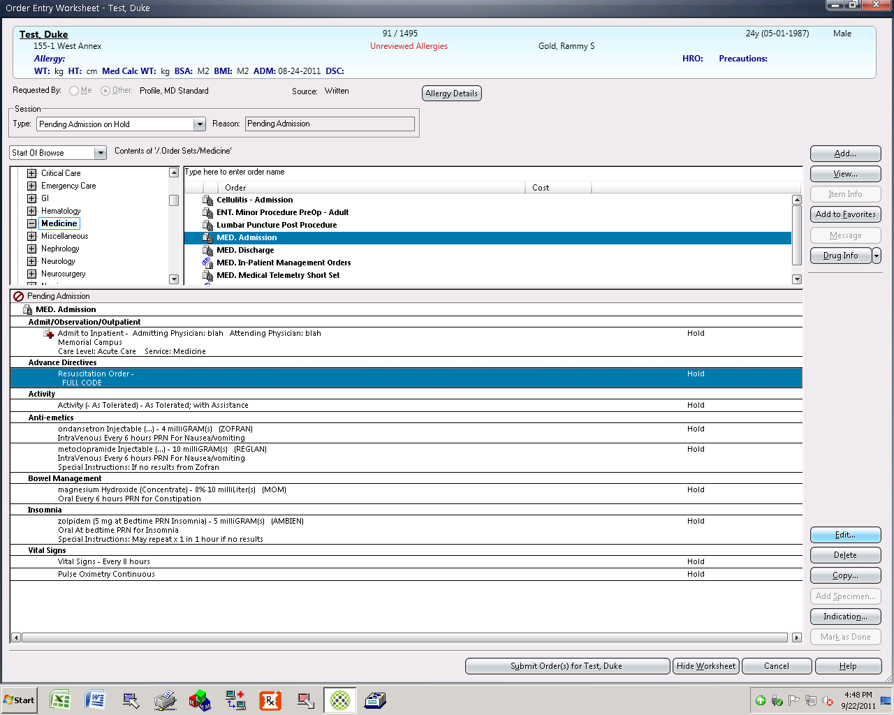

When it is time to release the orders, go to the order tab and select Release from the list of icons. You may click on Select All to check mark all orders. Click OK to release the orders. If any alerts need addressed they will automatically display.

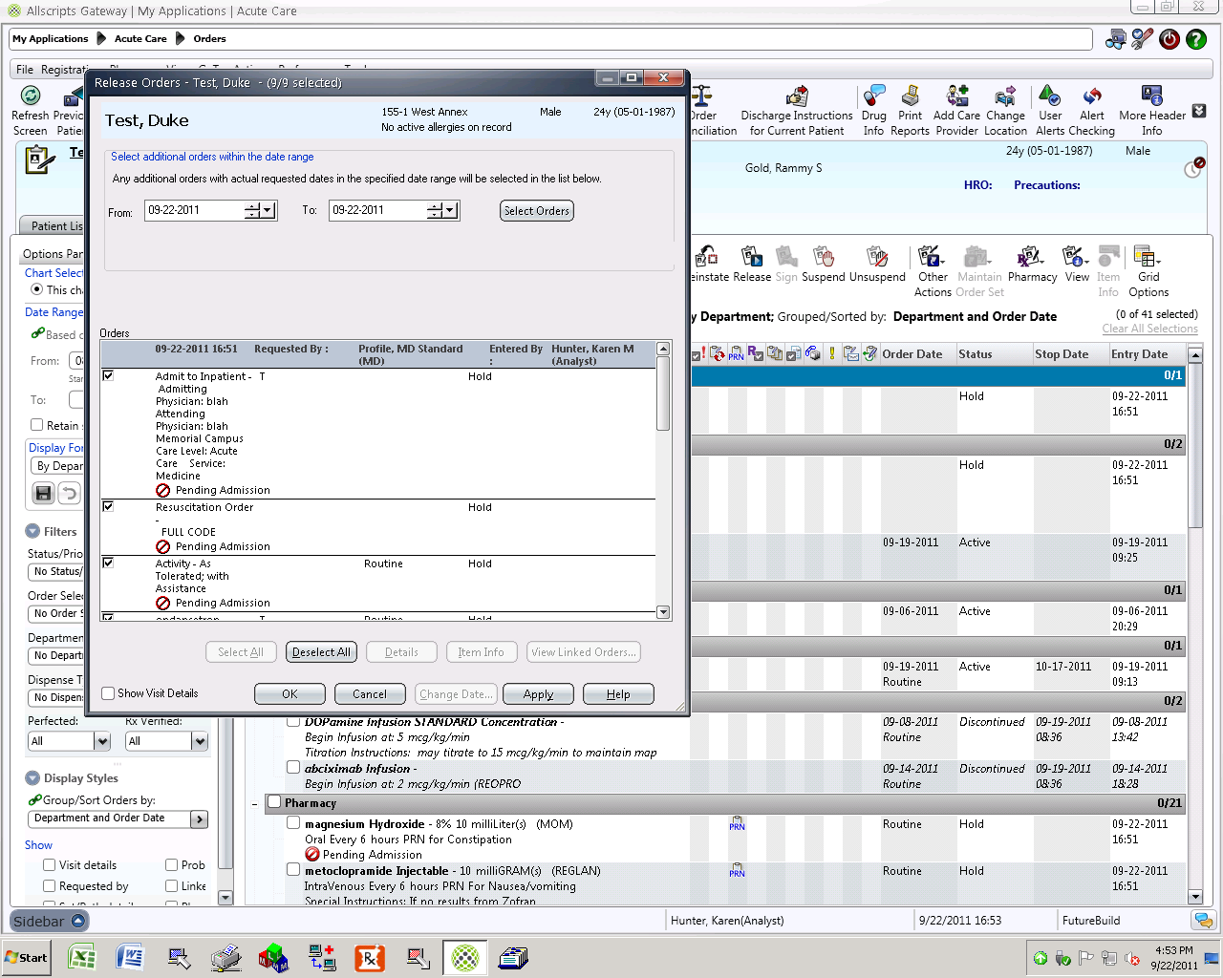

Hiding a Worksheet

Hiding the order entry worksheet allows the user to move to another tab, such as Results or Orders for that patient. For example, before an order is submitted, you may wish to review prior orders or results. You cannot move to another patient while unsubmitted orders remain on the worksheet.

Hide the Order Entry Worksheet with the two unsubmitted orders that currently display in the Summary area of the worksheet.

Before submitting the orders, you would like to review the patient’s previous chest x-ray.

- Click the Hide Worksheet button at the bottom of the Order Entry Worksheet.

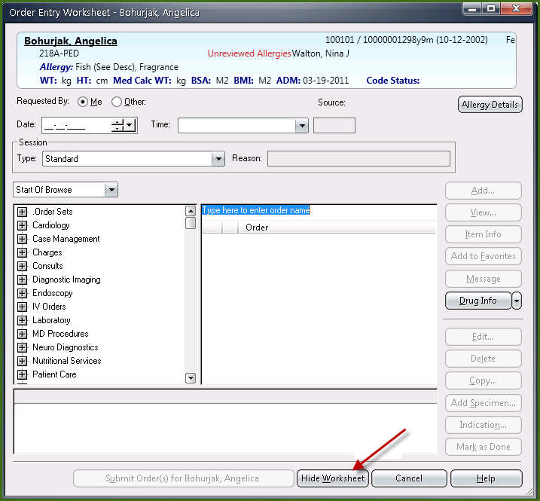

- Click the Results tab.
- Filter to only display Diagnostic Imaging results to view the chest x-ray result.

While you are reviewing the previous chest x-ray for this patient, your pager goes off and you must go to the ICU to see a patient. You try to log off before you leave.

- Click the Log Off button.

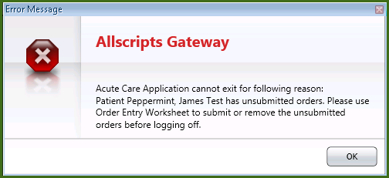

Note: A warning message displays: You cannot log off the application unless orders entered on the worksheets have been submitted.

- Click OK to the warning message.

- Click the Enter Order icon on the toolbar. Note: Notice it now displays as a clipboard with a picture on it. 

- Submit the orders.

Add Specimen before Submitting the Order

This function demonstrates the process for when a specimen is nurse collect on the floor and the specimen was collected before the order is entered (submitted).

If a specimen collection was done before submitting the order, you can mark it as being collected, noting the date and time.

Enter an order and mark specimen collected before submitting.

- In the order search field, type: cbc

- Click CBC(Complete Blood Count without Diff) from the options displayed. Make sure to fill in the mandatory collection time field as STAT.

- Click Add, but do not submit the order.

- Highlight CBC(Complete Blood Count without Diff) the order from the Order Summary window.

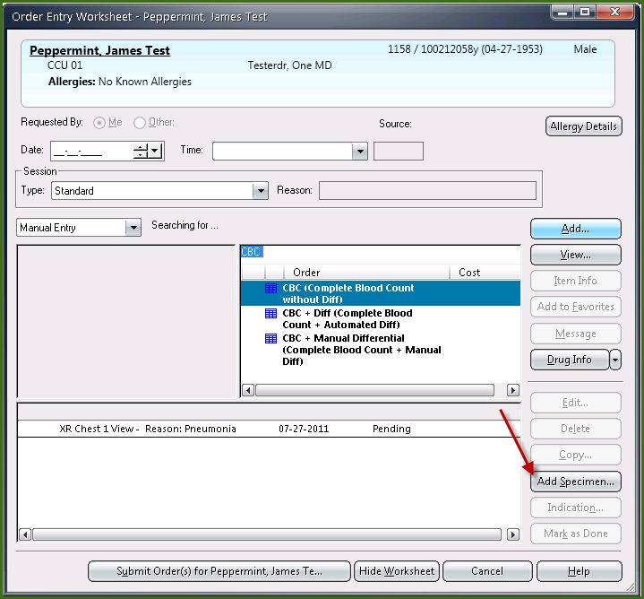

- Click the Add Specimen button located at the bottom, right corner of the worksheet.

Note: Notice the selected order is defaulted as checked.

- Review the Collection Date and Time fields that have been defaulted with the current date and time.

- Click in the Collection Volume field and type: 5.

- Click in the Unit of Measure field and type: ml.

- Click OK.

Note: The status of the order now reads Collected.

- Click Submit.

Enter a Nursing Order

- With your patient selected, access the Order Entry Worksheet.

- In the order search field, type: elevate.

- Select the Elevate HOB order and click Add. The order is added to the Summary area of the worksheet.

- Click Submit.

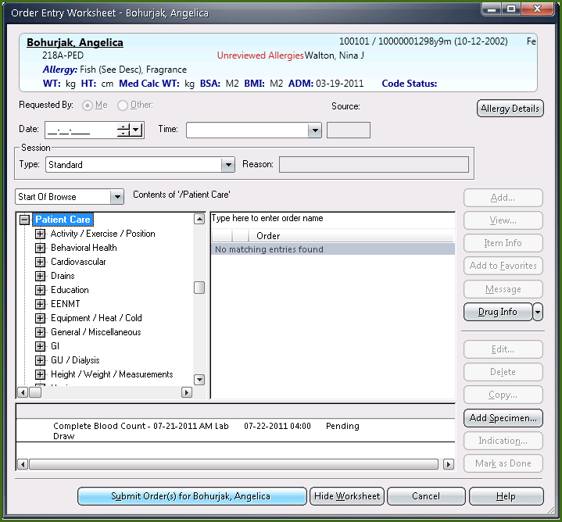

Some orders are set up to automatically be added to your flowsheets and/or worklists when they are ordered. Some of these include Neuro checks, dressing changes, IV drips, etc.

Entering a charge order

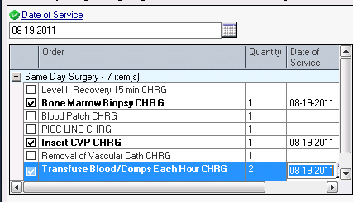

- With your patient selected, access the Order Entry Worksheet.
  - NOTE: Charges must be entered on behalf of yourself because the doctor does not have access to enter orders!

- In the order search field, type in %charge. The percent sign is your wildcard lookup and can be used to search for any order.

- Select the “Same Day Surg Charges order and click Add. The screen above displays. Enter the default Date of Service and click on the charges needed. Change the quantity as appropriate and click “OK”.

- The order is added to the Summary area of the worksheet, showing each individual charge.

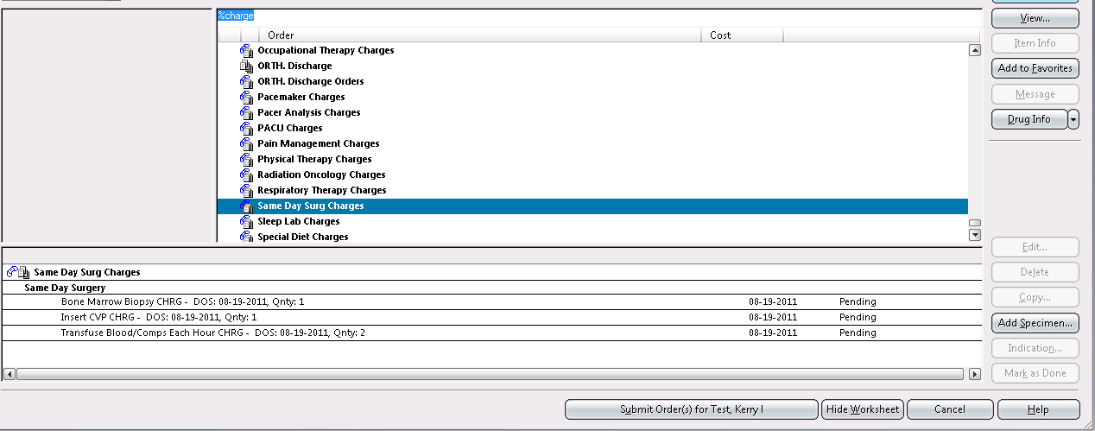

- Click Submit Orders.

Enter a Respiratory Order

Enter a respiratory order- Chest Percussion Therapy Initial

- With your patient selected, click the Enter Order button.

- Select the Requesting Provider and Source.

- In the order search field, type: CPT

- Select the Chest Percussion Therpay order and click Add.

- Complete any required fields on the order form.

- Click OK on the order form.

- Submit the order.

Enter a Repeat Order

Repeat orders are orders that will repeat over a period of time (e.g. every day at 0800).
Enter a Repeat order using the Start of Browse.

- Click the drop-down arrow and change the Manual search to Start of Browse.

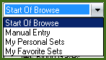

- In the Start of Browse area, click the plus sign next to Laboratory, then Chemistry, then General Chemistry.

- Select the Alkaline Phos order and click Add.

- On the order form, click the Repeat button at the bottom of the window.

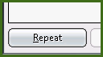

- Complete the following on the Repeat Order dialog box:

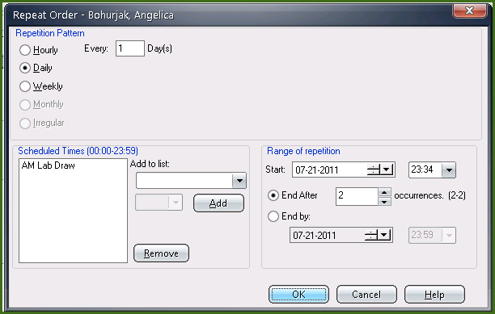

  - Leave Daily, every 1 day
  - Highlight Routine and click Remove.
  - Click the Add to list drop-down and select Time Critical
  - Click the Time selection drop-down and select 0900
  - Click the Add button
  - Change the Start Date to tomorrow’s date and Start Time to 0900.
  - Change the number in the End After field to 3
  - Click OK

- Click Add on the order form.

Notice the icons and how the orders display in the Order Summary window:

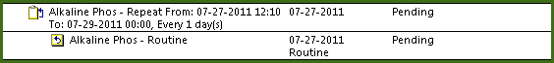

- The first order (with clipboard icon and arrow) is the Master order
- The second order (indented with paper icon and arrow) is the first repeat order occurrence (child order).
- The remaining repeat occurrences will not display until a configured number of hours/days before the schedule occurrence.
- Submit the order.

Enter a Conditional Order

Conditional orders are orders that do not become active until a defined condition has been met (e.g. “if give Zofran 4mg IV prn if N/V”). Once the condition is valid, the order must be activated to become active.

Enter a Conditional order.

- In the Order Search field, type: blood.

- Select the Blood Culture order and click View.

- Click the Conditional Order checkbox at the bottom right of the form.

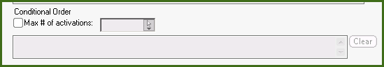

Notice the max # activations and condition text field are now required.

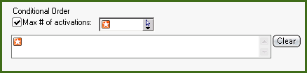

- From the drop-down, select Once.

Other options:

- Unlimited = if condition occurs, the order may be activated an unlimited number of times
- Specify = if condition occurs, the order may only be activated the specified number of times

- In the text field, type the condition: “if temp greater than 101.4”.

- Click Add.

Notice the blue question mark icon next to the order in the Summary window.



Enter a PRN Order

Enter a PRN order.

- In the Order Search field, type: Tylenol

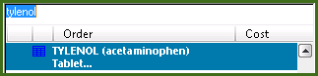

- Select the Tylenol order and click Add.

- Complete the required fields.

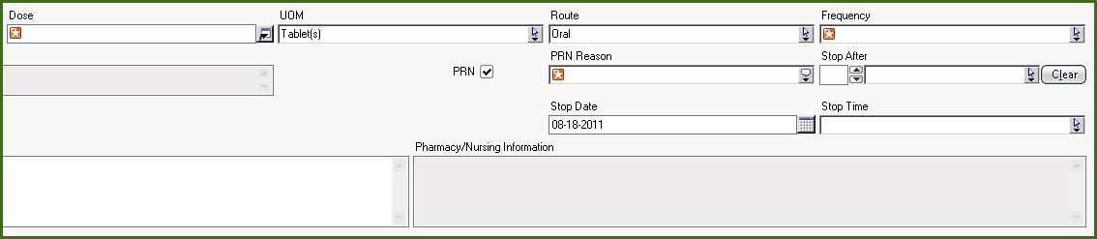

- Click the PRN checkbox.

If PRN selected, the PRN Reason is required.

- In the PRN Reason field, select pain.

- Submit the orders.

Enter an Order Triggering an Alert

During the order entry process, defined order parameters may trigger an alert or warning message based on the patient condition, for example, a drug/allergy conflict or duplicate order. The alert window will display in which you must make the appropriate clinical decision based on policy and/or provider instructions.

Enter an order that will trigger an alert (Ex. Drug/allergy alert).

- In the Order Search field, type: pen.

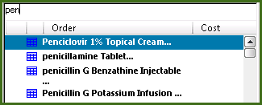

- Select the penicillin V Potassium order and Add it.

Note: The Alert Detail dialog box displays.

Features in the alert dialog are as follows:

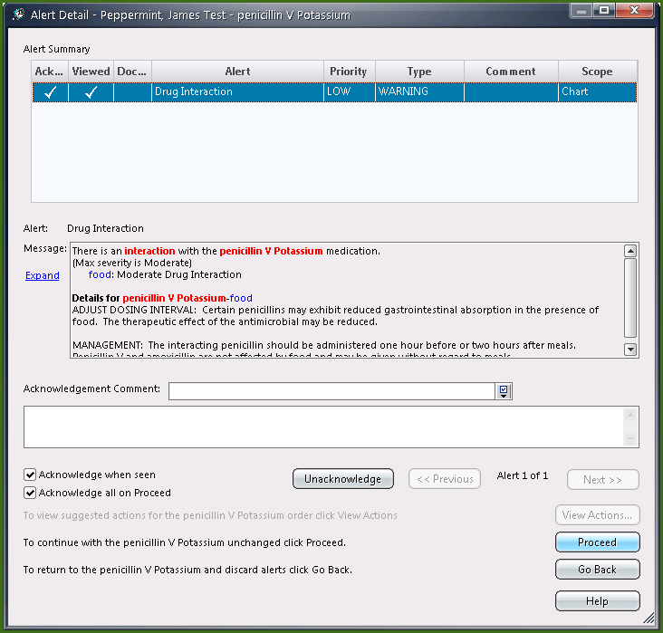

Alert Detail

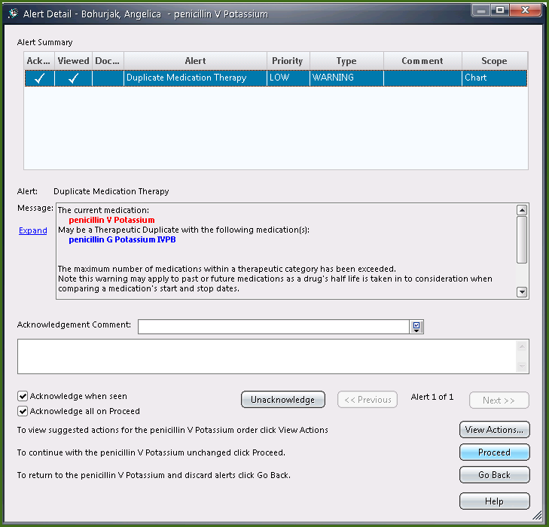

Section | Description
Alert Summary | Provides summary information including the alert type and whether or not the alert has been viewed and/or acknowledged. Should this action have generated more than one alert, they would list here.
Alert Message | Provides specific clinical details about the situation that caused this alert to generate.
Acknowledgement | Should users have the right to do so, they can acknowledge and enter reasons for the decision made.
Action Buttons | - View Actions – Select to display appropriate actions that can be taken relating to this alert  - Proceed – Select if you wish to continue with the initiating action  - Go Back – Select to discard the alert

- Click Acknowledge.

Note: Clicking Acknowledge assumes that you have read and take responsibility for the alert.

Note: Once acknowledged, a checkmark displays in the Ack column of the Alert Summary section of the dialog.

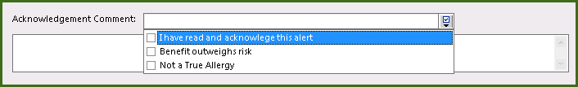

- Select an option from the Acknowledge Comment drop-down list OR type a comment in the free-text field.

- Click the Proceed button and complete the order form fields as required.

- Click Submit.

+++++++++++++++++++++++++++++++++++++++++++++++++++++++++++++

STOP HERE FOR THE END OF BASIC ORDER ENTRY!

+++++++++++++++++++++++++++++++++++++++++++++++++++++++++++++

3: Advanced Order Entry

This section introduces the Advanced Order Entry functions that focus on the functionality of how to enter more complex orders.

Enter an IV Drip Medication

Enter an IV Drip Medication.

- Select your patient from the patient list.

- Click the Enter Orders icon.

- In the order search field, type: dopa.

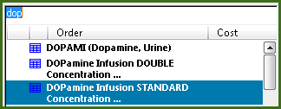

- Double-click the DOPamine Infusion STANDARD Concentration order.

- Enter a start date and time of tomorrow AM.

- Type 5 in mcg/kg/min).

- In the Administration Instructions field, type: To keep Systolic BP greater than 90.

- Click OK on the order form.

- Submit the order.

Note: IV drips will automatically be added to the vital sign and I&O flowsheets for your convenience.

Enter an IV Order with Additives

Enter an IV order with Additives.

- In the Order Search field, type: D5W.

- Select the D5W and add it.

- Complete required fields

- Click the icon at the end of the Additives field.

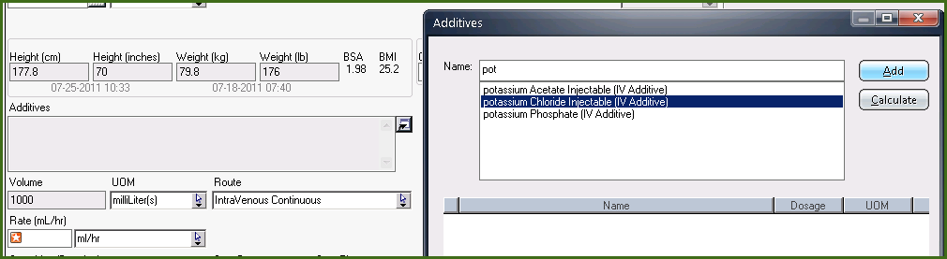

The Additives dialog box displays.

- In the Name field, type potassium.

- Select the Potassium Chloride Injectable(IV Additive) and click Add.

- In the Dosage field, enter 20.

- From the UOM drop-down list, select mEq.

- Repeat the process to add additional additives.

- Click OK.

The additive information displays in the Additives field on the order form.

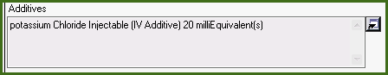

- Click OK on the order form.

Enter a Variable Dose Order

When entering an order, you can specify a variable dose that is titrated based on changing lab parameters. For example, you can specify a sliding-scale insulin order based on glucose levels.

Scenario: Your patient has a history of diabetes. It is decided that your patient’s dose of insulin needs to be adjusted according to his/her blood glucose levels which are being tested 4 times a day. Your patient’s glucose levels have been consistently high, so the ordering physician needs to add to the existing prebuilt sliding scale.

Enter a Variable Dose order.

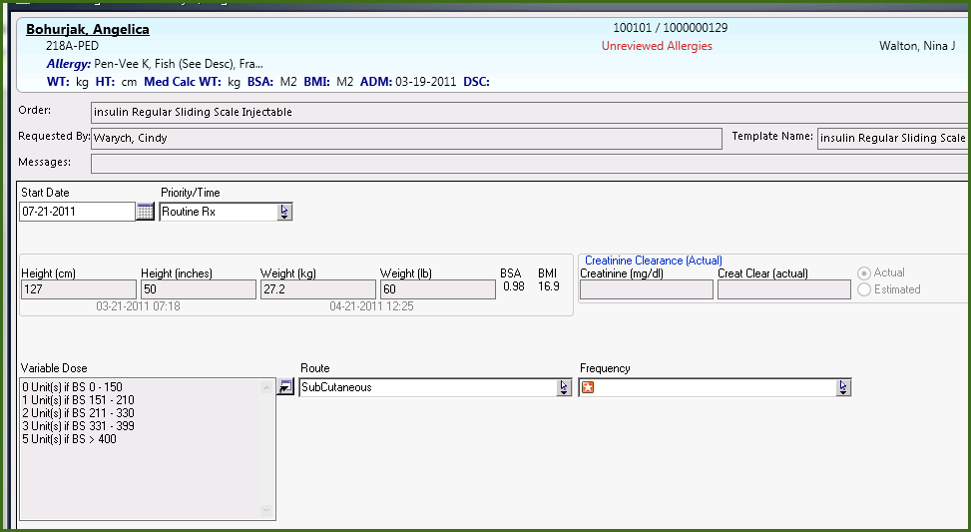

- Click the Enter Orders icon and find the order item: insulin Regular Sliding Scale Injectable Standard Pediatric
- Click Add to open the order form.

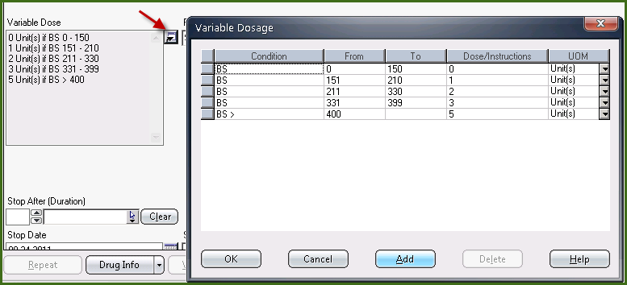

Note: The entries in the Sliding Scale Dose field are already there. You want to add more.

- Click the icon at the end of the Sliding Scale Dose field to open the variable dosage dialog.

Note: The data has been copied to the next line.

- In the To field, type 450, which is the high value for this glucose level range.

- In the Dose / Instructions field, type: 7, which is the desired amount of insulin to be given for a result in this range.

- Click Add to create the next entry.

- In the From field, type: >450.

- In the Dose / Instructions field, type: Call MD.

- Click OK.

- Select 4 times/day pre meal/bedtime from the Frequency field list.

- Click OK on the order form and Submit the order.

Enter a Tapering Dose Order

When entering a tapering dose order, you can specify the initial dose and then subsequent doses from a single order form. You enter the information on the order form, and the application creates child orders from the master order.

Scenario: Your patient has been on a long-term steroid treatment program and will be discharged from the hospital on a Prednisolone taper. This taper will slowly wean the patient by decreasing the dose in small increments. The ordering physician has prescribed the following taper: Prednisolone 15 mg qid x 12 times, then 10 mg qid x 8 times, then 5 mg qid x 8 times.

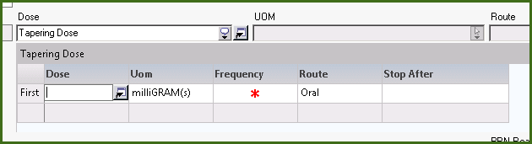

- Click the Enter Orders icon.

- Find the order item methylPREDNISolone then click Add.

- Click the Dose field drop-down arrow and select Tapering Dose.

Note: The order form lines drop down to accommodate the dosing option grid. The fields on the form included in the ordering grid are grayed out.

- Type 12 in the cell next to the Initial Dose field.

- Type mg in the Units (UOM) field.

- In the Route field, enter oral.

- In the Frequency field, type: qid (4 times a day).

- In the Duration field, type: 1 and select Times from the drop-down list.

Note: An additional line in the grid is created with the title of Last Dose.

- Type 8 in the Dose field.

Note: The units of mg and the route column are pre-filled from the cell above. The frequency of qid has not been pre-filled from the cell above.

- Enter qid in the Frequency field.

- Enter 8 times in the Duration (Stop After) field.

- Place your cursor in the cell below the Dose field.

Note: A new row displays with the last dose. The row label of the above entry changes to & Then.

- Type 8 in the Dose field, and qid in the frequency field.

- Tab to the Duration field to enter 8 times.

- Add one additional row by selecting the Dose cell.

- Type 4 in the Dose field, and qid in the Frequency field.

- Leave the duration open or empty on the Last Dose row.

Note: If you ever accidentally click on the Dose field and create a new row, and you want to remove it, just click on the row and use the Delete key to remove it. This can be done on any grids such as this.

- Click Ok.

Note: The order displays in the Summary area with a multiple order indicator.

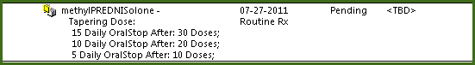

- Submit the order.

Enter a Multiple Frequency Order

When entering orders with multiple frequencies, you specify the initial frequency and then subsequent schedules from a single order form. You enter the information on the order form, and the application creates child orders from the master order.

Scenario: Your patient has just returned from the Cardiac Cath lab and needs frequent Vital Sign Observations. The ordering physician has requested the following Vital Sign order: q15 minutes x2, then q30 minutes x2 times, q1hour x2 times, and then q4 hours.

- Click the Enter Orders icon.

- Find the order item Vital Signs.

- Click View.

- In the Frequency field, select <multiple>.

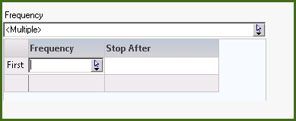

Note: The order form lines drop down to accommodate the frequency option grid.

- In the Frequency column, click q15min.

- In the Stop After field, type 2 times.

- Place your cursor in the field below the Frequency field.

Note: A new row displays. The new row label of Last displays.

- Select q30min.

- Tab to the Stop After field and enter 2 times.

- Add one additional row by clicking in the Frequency cell.

- Select q1h.

- Tab to the Stop After field and enter 2 times.

- Click the Frequency field again, and select q4h.

- Leave the duration open or empty on the Last row.

- Click Add.

Note: The order displays with a multiple order indicator.

- Submit the order.

Enter a Now and Then Order

Scenario: Due to your patient’s condition, the ordering physician has requested Medrol 20mg Now and Then 5 mg.

- Click the Enter Orders icon.

- In the order search field, type: Medrol.

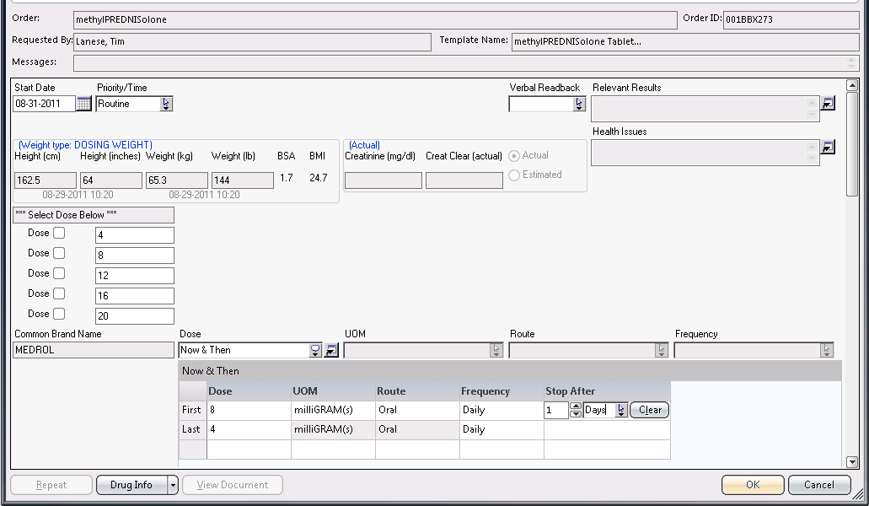

- In the Dose (from) field, select Now and Then.

- In the Now Dose field of the dosing option grid, type 20 (units = mg).

- In the Dose field, type 5 in the row label & Then.

- In the Frequency field, select bid (Twice a day).

- Click OK.

- Submit the order.

Enter an Order Using Dose Calculation

Note: This demonstration may only be required for Pharmacy/ Physician user training sessions.

Up until this point, you have entered medication doses manually in the dose fields on the form. In addition to this, you can calculate doses using the calculated dose order form field.

Scenario: Your patient has a condition which requires you to order some antibiotics for him or her.

- Click the Enter Order icon.

- In the order search field, type: genta.

- Double-click the Gentamicin order.

- Enter a start date and time of tomorrow AM.

- If the patient does not have an existing admission height and weight displayed in the fields at the top of the form, click the icon at the end of each field and enter appropriate values for each. Click Yes to save to the permanent record.

- Click the icon (with arrow) at the end of the Dose field.

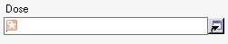

Note: Your patient’s height, weight, BSA, BMI weights display.

- Hover your mouse over the BSA and BMI values to see the calculations used.

- Click the icon (with arrow) at the end of the Wt (kg) field.

Note: The Available Weight Types dialog displays, allowing you to choose which weight you want to base this calculation on.

There is only a current weight documented against your patient.

Note: Other weight types are documented in flowsheets.

- Click the WEIGHT entry.

- Click Select.

- Using the Per Dose Requirement calculation (default as selected), type 1.5 in the Requested amount per dose field.

- In the UOM field, click mg.

- Select Kg (adjusted) from the per field options.

Note: This will calculate this dose based on the adjusted weight listed in this dialog.

- Click the Calculate button.

Note: The calculated dose displays in the Ordered Amount Per Dose field. At this point, you could accept the calculation or adjust any value and recalculate. You may then be required to enter a reason for the override.

- Select Q8H in the Frequency field.

- Click the Calculate Total Daily Dose checkbox.

- Click OK to accept the dose.

- Review the information that displays in the Calc Info: field on the form.

- In the In Base Solution fields, type Normal Saline 100 ml.

- Click OK.

- Submit the order.

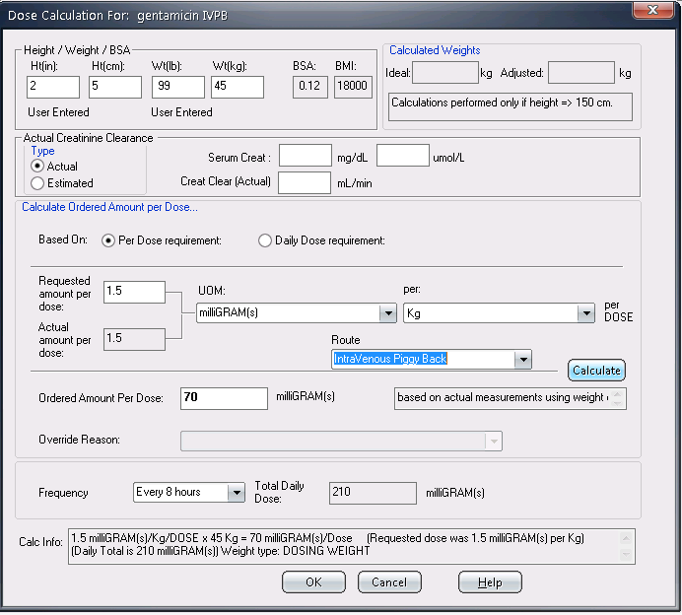

Enter Orders on Hold

Scenario: Your patient may be going to surgery. The ordering physician has reviewed his or her chart and needs to add some orders to be done pre-operatively.

- Select your patient from the patient list.

- Open the Order Entry Worksheet.

- From the Session Type drop-down list, select Pre-Op Orders on Hold.

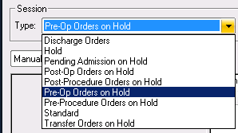

- Manually search and add the following orders to be held until the OR is ready for your patient:
  - Morphine 2 mg IV STAT
  - Platelet Count – view the order form and select STAT in the Collection Time field

Note: These orders display with a unique Hold order icon (red circle with slash) and are listed with a HOLD order status.

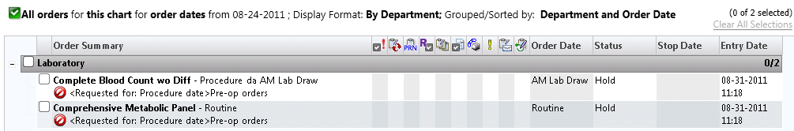

- Submit these orders.

Enter Order Set Orders (Multi-Order Set)

Order sets are a mechanism in SCM in which multiple orders can be entered from a single order form. For example, there may be a set of standard routine orders that should be entered on a patient at the time of admission (e.g., Medical Admission Order Set).

Scenario: You want to enter oral supplements for your patient.

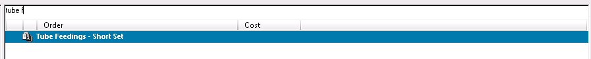

- Select your patient from the patient list.

- Click the Enter Orders icon.

- Find the order set name Tube Feeding – Short Set

  - Note that order sets have a multi-file icon next to them.

- Each order set is in a grid format as seen here. Check the orders you want to keep. Some may be pre-checked for you. When you have checked all the boxes you need, save your order and submit it.

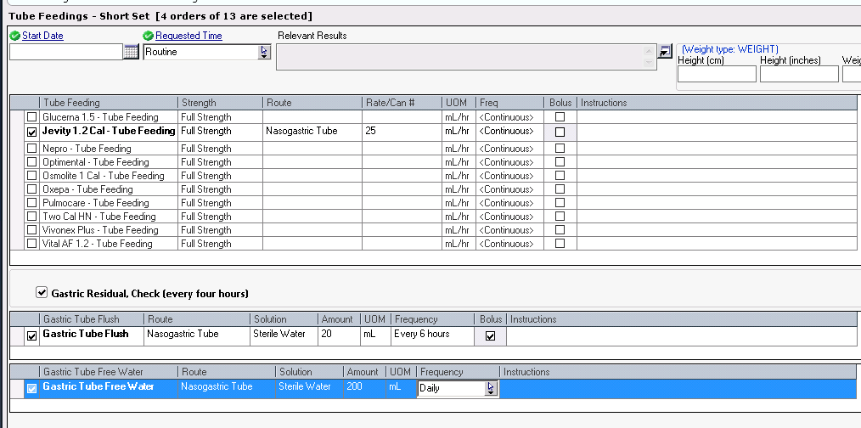

4: Order Review

Using Order Tab Filters

The Orders tab allows you to view all orders for a selected patient for any time period.

Various filters and display formats (similar to the ones available in the Results tab) are available so you can quickly retrieve the order(s) you need to see.

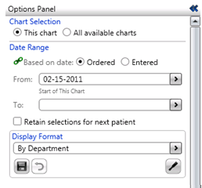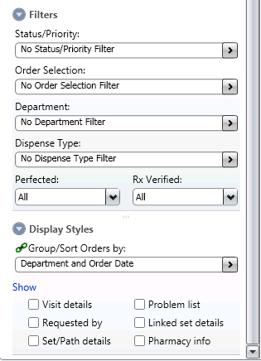

Viewing Orders

Section 1 Chart Selection
This Chart | - This option allows you to see orders for a specific visit
All Available Charts | - This option allows you to see orders for all visits for a patient
Date Range
Ordered | - This section allows you to filter the orders view by time period for a relevant date (Start of this Chart, Three days ago, etc)  - or a specific calendar date (drop-down arrow on the calendar date field)
Entered | - You can also filter an end date using the To field.
From / To

Section 2 Filters
Status/Priority | - This section allows you to filter the orders by status (Active, All, Discontinued, Pending Collection, etc)
Order Selection | - This sections allows you to filter the orders by type (Medication, Lab, Nursing, etc)
Department | By Department - In this view, the orders will be listed in beneath the department headers that they are associated with (Chronological or Reverse Chronological based on facility default).  - Point out status of the orders  - Point out the various symbols next to the orders  - STAT  - Conditional (question mark?)  - Hold (red circle with slash)  - Repeat (blue arrow in yellow box)  - Suspend/Hold (hand)  - Discharge (thumb up)  By Department/Extended – similar to the By Department view, but this view includes these additional elements:  - Rx Verified (related to pharmacy)  - Perfected (related to pharmacy)  - Requested By  - Department  - Order Set Name  By Department/Status - The orders are sorted by department in pre-determined order status groups. (Active, Hold, Pending, etc)  Linked Orders – displays orders that have been entered using the Dosing Option or Multiple Frequency feature. Orders are sorted based on the earliest start date of any of the orders in the group.  Order Sets – displays orders from Clinical Paths, Linked Order Sets, and Sunrise Pharmacy (if installed).  Requested By –  - The header information includes the date and time the order was entered and who requested the order.  - The Entered By person is also listed if the person requesting the order is different from the person who entered the order.  Requested By Details –  - This view simulates handwritten orders in a chart in the date sequence they were written.  - Additionally, any maintenance activity for an order and repeat order occurrences and order set groups are included here.  Therapeutic Categories – (available only if Sunrise Pharmacy installed)
Dispense Type | Dispense Sub-type – (only available if Sunrise Pharmacy installed)
Perfected | Perfected – (only available if Sunrise Pharmacy installed)
Rx Verified | Rx Verified – user can filter medication orders that require pharmacy verification  - All – displays all order types  - Yes – displays only orders that have been verified  - No – displays only orders that have not been verified

Section 3 Display Styles
Group/Sort Orders by | Priority – from the drop-down, the view can be filtered to show orders related to a specific order priority by clicking the appropriate checkboxes.  Status - from the drop down, the view can be filtered to show orders related to a specific order status by clicking the appropriate checkboxes.  Department - from the drop down, the view can be filtered to shows orders for specific department(s) by clicking the appropriate checkboxes.
Order Selection | Works same as the Standard tab.
Display Format | Works same as the Standard tab.
Sort Sequence | Date/Time - orders are sorted within each department by significant date/time in either chronological or reverse chronological order based on the user’s preference.  Order Name, Date/Time - orders are sorted within each department, first in alphabetical order by order name, then by significant date/time in chronological or reverse chronological order based on the user’s preference.  Date, Order Name - orders are sorted within each department first by Date, based on the Significant Date (time is ignored) in chronological or reverse chronological order based on the user’s preference, then by order name in alphabetical order.  Stop Date/Time, Order Name - orders are sorted within each department first by the order stop (or DC) date/time in chronological or reverse chronological order based on the user’s preference, then by order name in alphabetical order.  Order Type/Dispense Sub-type, Order Name - (available only for the By Department-Extended View when Sunrise Pharmacy is installed)

View Order Details

- Double-click on any order.  - Or highlight the order and right click to get the options to the right. Order Details will also bring up the order entry form. | The order form displays allowing you to view the details of the order entered during order entry.  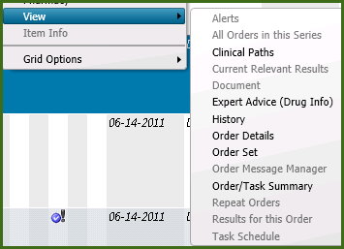

View Order Status History

- Right-click on the <order name> order.
- Select History > Status. | The Order Status History dialog window displays showing all history of actions performed on the order.  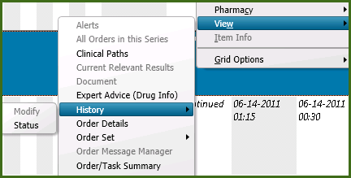  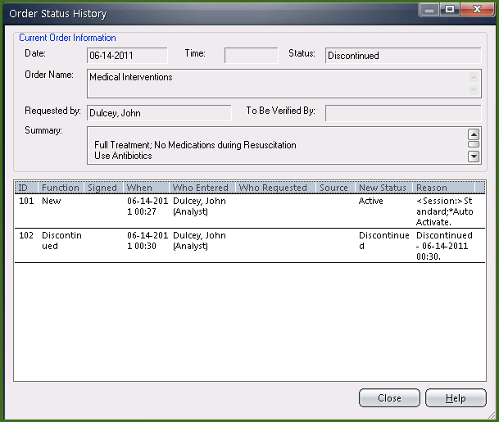

Orders Tab Icons

Hover over each Icon to see a description of the icon. Refer to handout given during class.

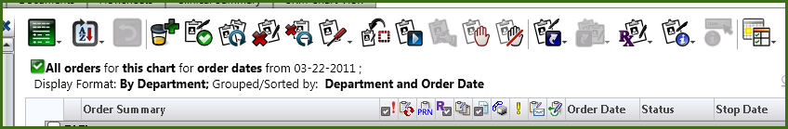

See page at end of manual.

5: Order Maintenance

Order maintenance functions let you change an existing order to reflect what is happening with the patient. For example, you can add specimen collection information to a test requiring a specimen or discontinue an order no longer needed for a patient.

Orders are suspended and unsuspended as determined by the clinician. Orders on hold can be released when appropriate. Previously discontinued or canceled orders may be reinstated.

Order maintenance functions can be accessed in multiple ways; however, in this guide we will focus on one method in the demonstration examples. There are 3 ways to access order maintenance functions.

- From the Actions menu
- Right-clicking on the order
- From the buttons above the orders

Modify Submitted Orders

Scenario: You realize that the D5W 1000ml at 750 ml/hr was ordered with an incorrect rate. IV rates are the only part of an order that you can modify.

Modify a Single Order:

- On the Orders tab, right-click on an order.

- From the short cut menu, select Modify Order > Requested by Other (or Requested by Me if this is a physician class). The order form displays.

- Change the IV rate field to 75 ml/hr.

- Click OK.

- Click the Refresh icon on the toolbar.

Note the IV rate displays next to the order and the paper with pen icon next to the order date denoting the order was modified.

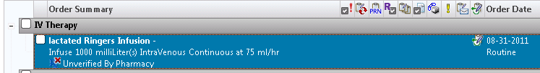

Activate a Conditional Order

When the condition that was placed on a conditional order has been met, you can activate the order so that it may be processed.

Scenario: The nurse needs to activate a conditional order. The condition placed on the order when it was submitted has been met; and the order needs to be processed.

- Select your patient from the Patient List and click the Orders tab.

- Highlight the conditional order that is Available for Activation.

Note: The question mark icon indicates the order is conditional.

- Right-click and select Activate.

The Order Entry Worksheet displays with the order ready to be submitted.

- Click Submit.

- Review the active order on the Orders tab in the By Department display format.

Note: If the conditional order had only 1 available activation, it displays in italics (indicating it is complete), and the order status reads Completed Activation and the <Available Activations = 0>.

- Change the display format to Requested by Details to see that the order was generated from the original conditional order.

Suspend and Unsuspend an Order

An active order that should be stopped temporarily may be suspended. For example, a diet order for a patient may be suspended while the patient is has a procedure, and later unsuspended when the patient returns to the nursing unit.

NOTE: Often, the same maintenance function must be performed on several orders. Both the Multi-select option under the Actions menu, and the buttons at the bottom of the Orders tab support this.

To suspend the order:

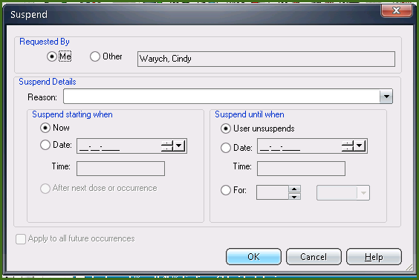

- Right-click the order to be suspended.

- From the short cut menu, select Suspend

- Select the Requested By provider as appropriate.

- Select the Source.

- Select the reason from the Suspend Reason drop-down list.

- Click OK.

Note that the order is now flagged with a hand symbol indicating a suspended order.

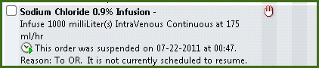

To unsuspend the order:

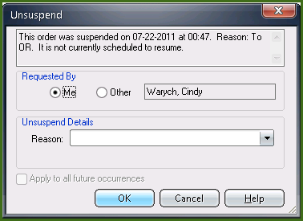

- Click the Un/Suspend button from the button bar at the bottom of the Orders tab.

- On the Unsuspend dialog window, click the Unsuspend radio button.

- Check the box next to the suspended order.

- Select Patient returned to unit from the Reason field.

- Click OK.

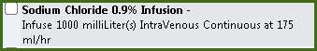

Suspend/Unsuspend of an order is communicated to the receiving department using the same mechanism as was used to communicate the original order.

Release Orders on Hold

Orders placed on Hold status may be released to active status once the patient event occurs. Once the hold orders are released, they are communicated to the performing department. Since orders can be released hours or even the day after it is submitted, the Requested date field will be populated with the date the order is released, rather than the date it was ordered.

SCM allows you the ability to release a single order or release multiple orders at one time. Note: This example will focus on the multi-order release function.

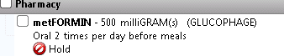

Click the Release icon at the top of the Orders tab.
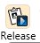

All orders that are available to be released are displayed on the Release Orders dialog window.
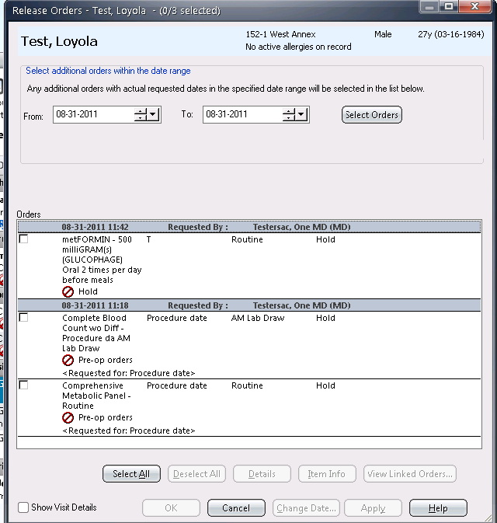

Note: When orders are Multi-selected for Release, they will present as unchecked. When single selecting an order (Right-click > Release), the order will present as pre-checked.

- Place a checkmark next to the order(s) to be released OR click the Select All button to select all orders.

- Click OK.

The Hold icons are no longer displayed on the Orders tab.

NOTE: To Release a single hold order, right-click on the order and select Release from the short cut menu.

Discontinue/Cancel Orders

In providing patient care, it is often necessary to discontinue one or more orders that were appropriate for a time, but no longer are. It may also be necessary to cancel orders that were entered for the wrong patient.

Scenario: The Attending Physician decides that your patient is no longer able to tolerate his or her diet and you want to discontinue the order.

SCM allows you the ability to discontinue/cancel a single order or multiple orders at one time.

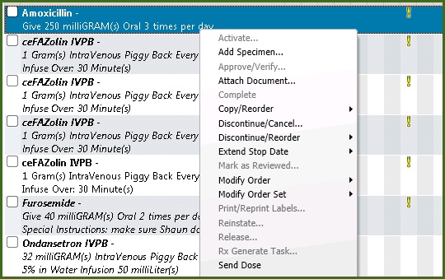

Discontinue/cancel single orders:
- On the Orders tab, right-click the (diet) order.

- From the shortcut menu, select Discontinue/Cancel.

- On the DC/Cancel dialog:

  - Select the, if appropriate, Requested By option (Me or Other).

  - Select an appropriate reason from the Reason field drop-down list or manually type a reason if the available selection list option is not appropriate.

  - Optionally, click the Date radio button to specify a specific date and time or leave the default of Now.
- Click OK.

The order displays in italics and has a status of Discontinued.

Discontinue/cancel multiple orders:

- Click the DC/Cancel… button at the bottom of the Orders tab.

All orders that are available to be discontinue/canceled are displayed on the Discontinue/Cancel Orders dialog window.

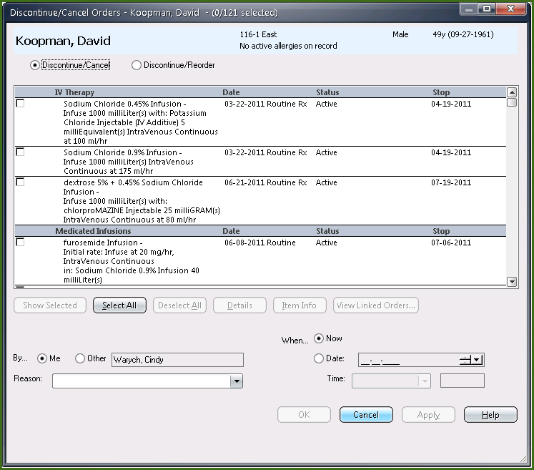

Note: To discontinue and reorder an item, click the Discontinue/Reorder radio button to change the action to this function.

- Place a checkmark next to the order(s) to be discontinued/canceled OR click the Select All button to select all orders.

- Select the, if appropriate, Requested By option (Me or Other).

- Select an appropriate reason from the Reason field drop-down list or manually type a reason if the available selection list option is not appropriate.

- Optionally, click the Date radio button to specify a specific date and time or leave the default to Now.

- Click OK.

Cancel an Order Set:

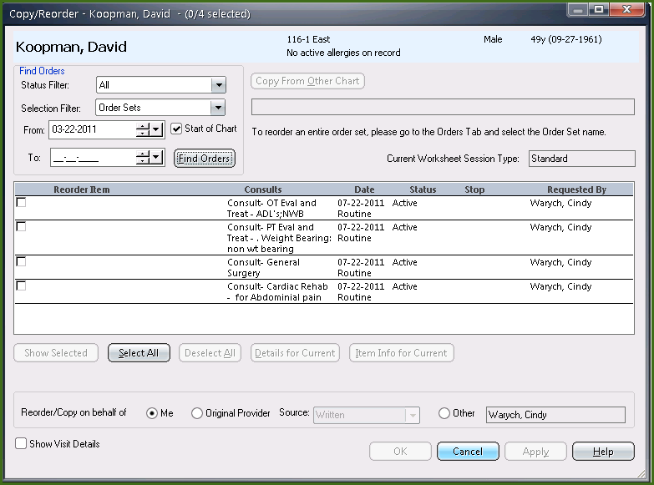

- Select the Requested By display format.

- Select the Order Sets option under the Order Selection filter.
- Right-click the order set.

- Select Discontinue/Cancel from the short cut menu.

The Discontinue/Cancel Orders dialog displays with only the orders belonging to the order set you selected.

- Ensure the orders are selected. All are pre-selected by default.

- Select a reason from the Reason field.

- Click OK.

Reinstate Canceled Orders

Scenario: The Attending determines that some of the orders canceled with the order set are still appropriate for the patient. He / She needs to reinstate them.

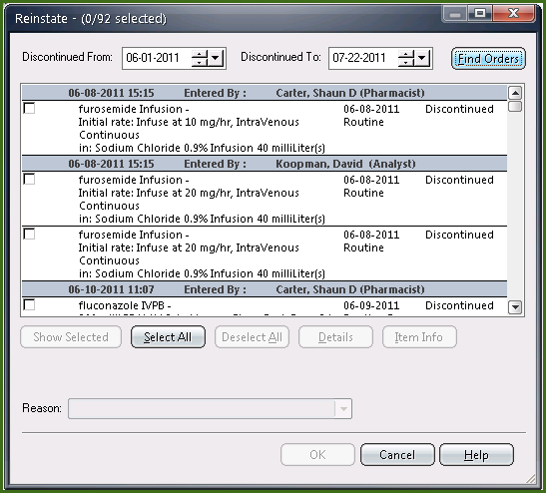

- From the Orders tab, click Actions > Multi-select > Reinstate from the menu or use the icon on the toolbar. 

- On the dialog window, if appropriate, select the Discontinued From date…the default is today’s date.

- Click the Find Orders button. All discontinued/canceled orders display.

- Click the checkbox next to the appropriate orders to reinstate.

- Select the appropriate reason from the Reason field.

- Click OK.

The orders are placed on the Order Entry Worksheet. At this time any edits could be made.

- Submit the orders.

Add Specimen Information

This function provides the ability to add specimen information after the order has been submitted.

Scenario: While doing your assessment on your patient, you obtained the urinalysis for her lab tests, and wish to add the information into Clinical Manager.

- On the Orders tab, click the Add Specimen icon  at the top of the window.

- Click the Specimen Type drop-down list.

- Select Urine.

All orders with a specimen type of urine that are eligible to be collected are displayed. If there is only one order, it will present preselected.

Note: The Specimen Collected by: name defaults to the person who collected the specimen.

- Select No. of Labels to Print = 1.

- Enter 100 in the Collection Volume field.

- In the Unit of Measure field, type: ml.

- Click OK.

The urinalysis order will now display with a status of Collected on the orders tab.

You can also add specimens from the order entry window if you are entering an order or the right click menu option when you are in the orders tab and have an order highlighted.

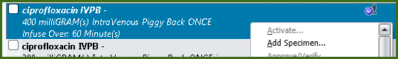

Reorder an Item

You have several options for reordering. The Current item option copies all the information from the current order except for requested date and time. You can also select from a list any of the predefined orders for this item, or order the original item.

Scenario: While reviewing orders for your patient, you see the medication order that you would like reordered.

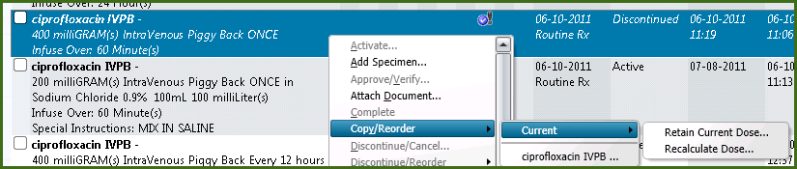

- From the Orders tab, right-click the an order.

- From the shortcut menu, select Copy/Reorder > Current, then select Retain current dose or Recalculate dose.

Note: When a user reorders an item that he or she had not originally requested (Requested By), the original provider is retrieved in the dialog box. However, the radio button defaults to No, which does not retain the original requesting provider.

- On the Retain Requested By Original Provider dialog, select Yes to retain the original provider.

This brings you into the Order Entry Worksheet where you can check the order and submit it.

- Click Submit.

NOTE: When reordering a medication that uses the Calculated dose field on the order form, you have additional selections. You can chose to retain the current dose which will reorder the medication with the original calculated dose, or you can chose to re-calculate the dose. If recalculating the dose, the application will look to the patient’s current height/weight/BSA and automatically recalculate the dose based on that information.

You may also use the Discontinue/Reorder option which will DC the current order and leave only the new order as active.

Order Message Manager

Nursing and Pharmacy are able to communicate missing doses etc… via the Message Manager. If you right click on a medication order, select View then Order Message manager, you can create a New Message and track any replies to older messages. The specific drug information is listed at the top when you right click on the drug that you need.

Not only does order messaging allow you to send a message requesting a dose,
but it also allows the pharmacist the ability to generate a dose form within the
message, along with labels and billing. The transaction is on record and available
for later review/audit.

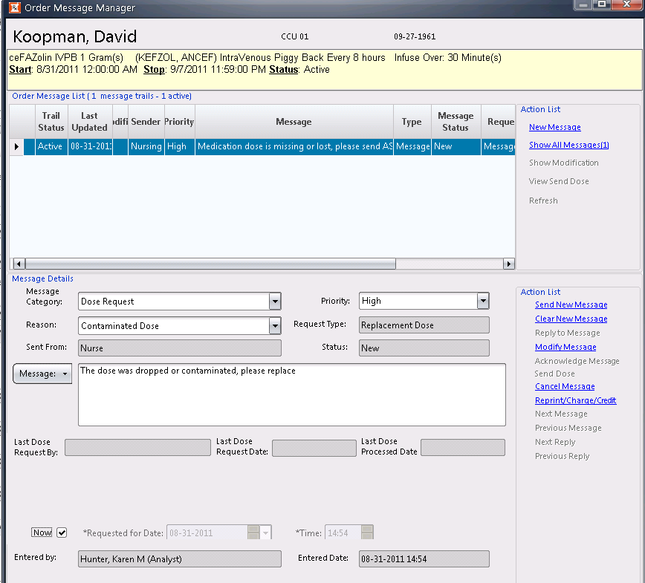

- Click New Message.

- Select Dose Request from the Message Category drop-down list.

Caution: Dose requests may be made only for active, pharmacy-verified orders, though regular messages may be sent on orders still waiting to be verified in the pharmacy.

- Select Dropped Dose from the Reason drop-down list.

The Request Type populates and it determines which other fields appear in the message form.
The Request Type prints at the top of the pharmacy label it generates.

The default Priority and message text configured for the Reason appears on the message form. You can change either one.

Hint: To prevent duplicate requests if a previous dose request exists for the order, information appears regarding the most recent one. It includes: name and occupation of requestor, date and time of request, and date the last dose was processed (unless it states Pending for an order not yet processed).

- Select the Now check box.

Note: The shaded areas are read-only fields.

Click Send New Message on the right side of the screen.

NOTE: You will get a flag on your patient list in the Msg for Nsg when pharmacy answers your message. If you also have the Msg for Pharm column, you will see a flag when you have sent a message.

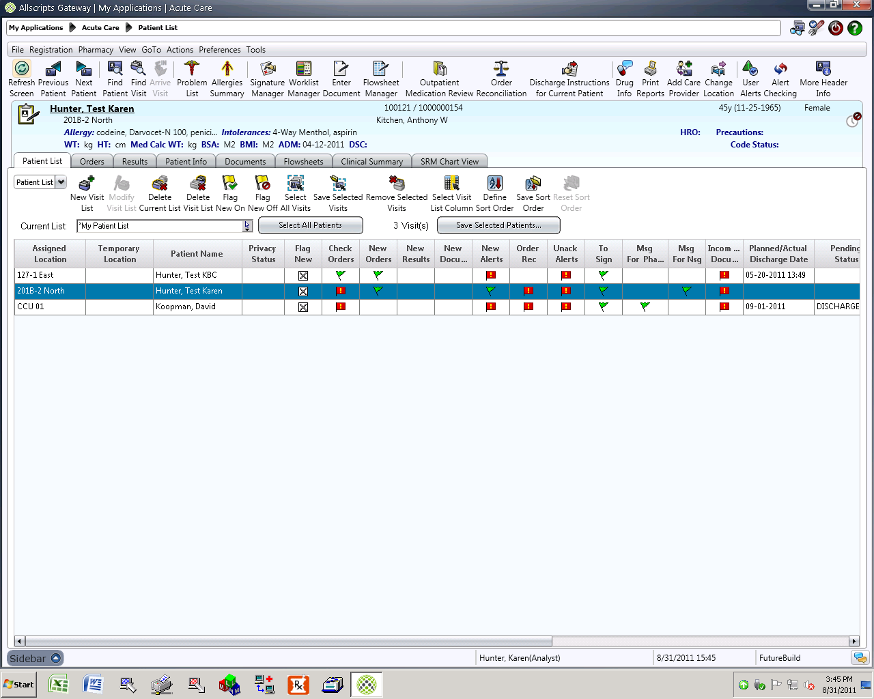

On the orders tab, you will see these icons display next to the order as messages are

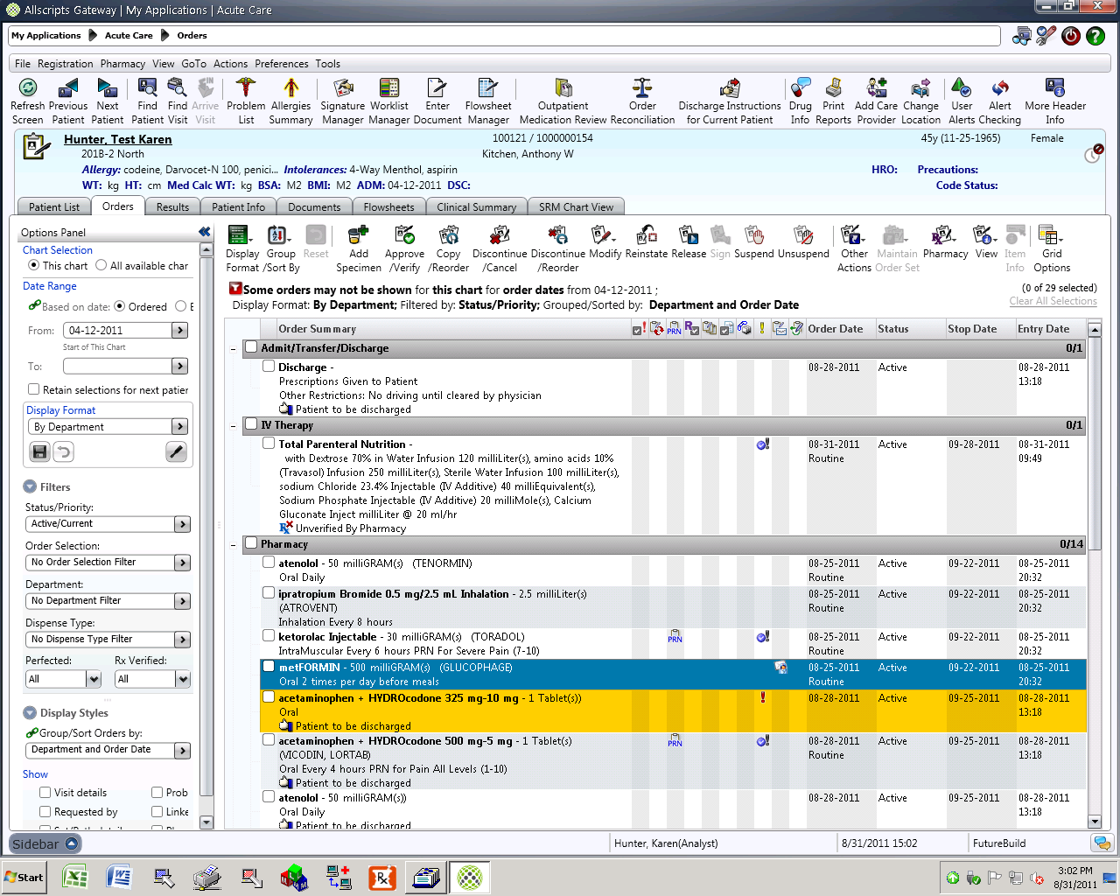 This icon appears when you have sent a message to pharmacy.

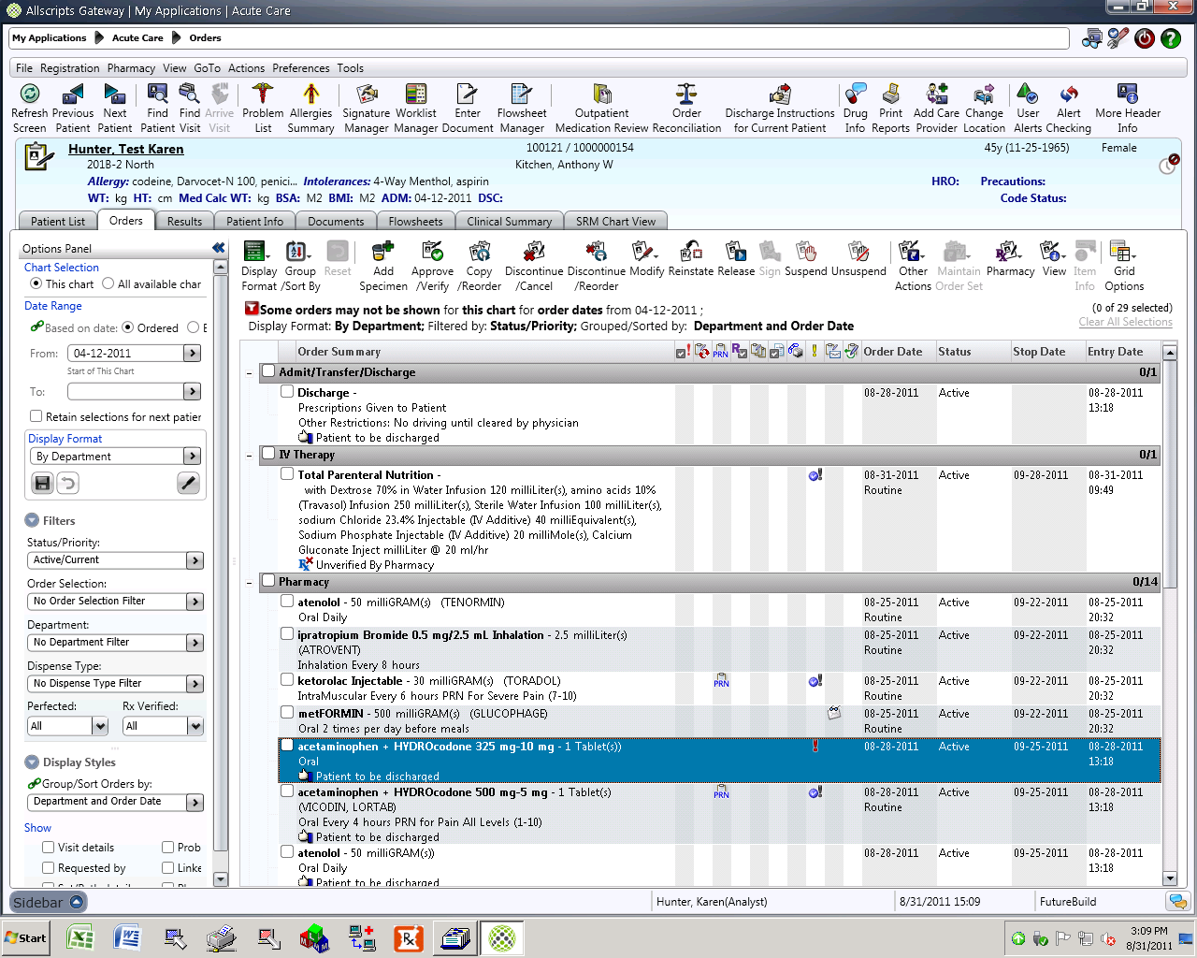 This icon appears when pharmacy has read the request.

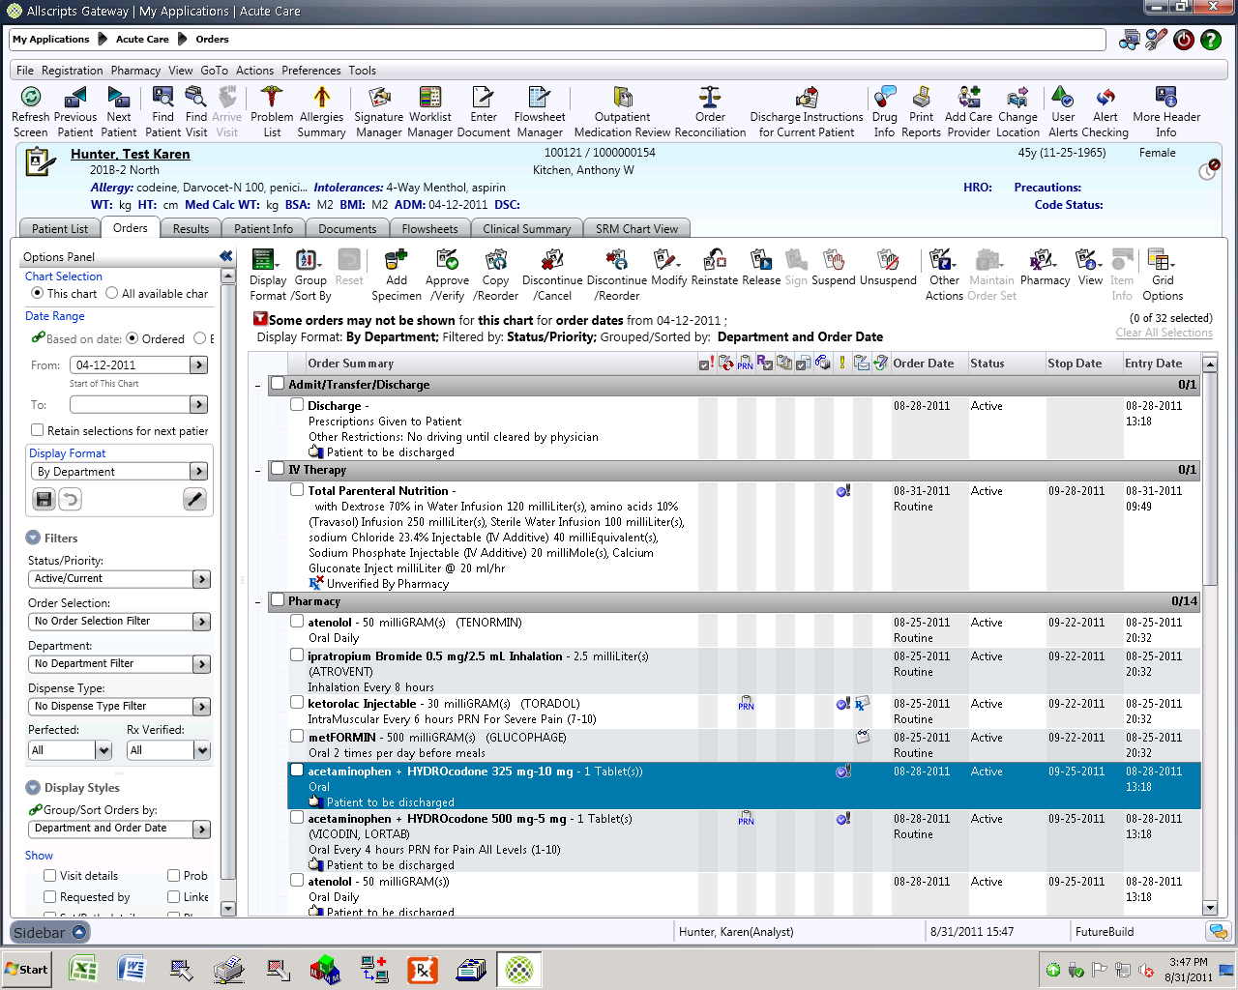 This icon appears when pharmacy has replied to your message.

6: Signature Manager

Physicians are notified of orders needing their signature whenever an order is entered, modified, or maintained on their behalf; that is, they have been named as the requested by provider. If a doctor enters an order requested by him or herself, then that order will not trigger the To Sign flag.

Dependent on your workflow, orders are entered by users who are not providers, for example a dietitian or physical therapist. Your policy then dictates that these orders be approved/verified by licensed personnel with the appropriate authority such as a Registered Nurse or a Physician.

These orders must then go through a verification process. Orders can be entered but will remain in a Pending Verification state (inactive) until they are verified. At that time the orders are activated and are transmitted to the performing department.

Both order signature and order verification are done using Signature Manager.

Sign Orders

Scenario: You, as the provider, see a red flag in the To Sign column against your assigned patient.

There are two methods for accessing Signature Manager:

- To sign orders for an individual patient, double-click the flag in the To Sign column

- To sign orders for multiple patients at once, click the Signature Manager icon on the toolbar

A red flag indicates there are orders that require a signature because the

orders were placed by someone else on the provider’s behalf. A green flag

 means that the order requires signature by someone else OR if you belong to a group of clinicians (Signature Group), you would have the ability to sign it.

Note: Signature Manager is also used to sign tasks and documents if required.

- Ensure you are logged on as the signing physician.

- Select the appropriate assigned patient with orders requiring signature.

- Double-click the red flag in the To Sign column.

The Signature Manager displays in signature mode. All checked orders indicate your signature is required.

You may also see the following:

- Those orders that you can sign because you’re part of a signature group. The check box will be unchecked with a little blue checkmark next to it.

- Red exclamation point on an order means it has unacknowledged alert, blue means acknowledged. Click the Alerts button to see the Alert on an order and to acknowledge an unacknowledged alert.

- Orders in light gray mean you can’t sign those orders for the patient, but have security to see them.

Signature Manager Filter Panel
If you have access, you may use the Filter panel on the left side of the Signature Manager window to limit the view to only orders to be verified and signed.
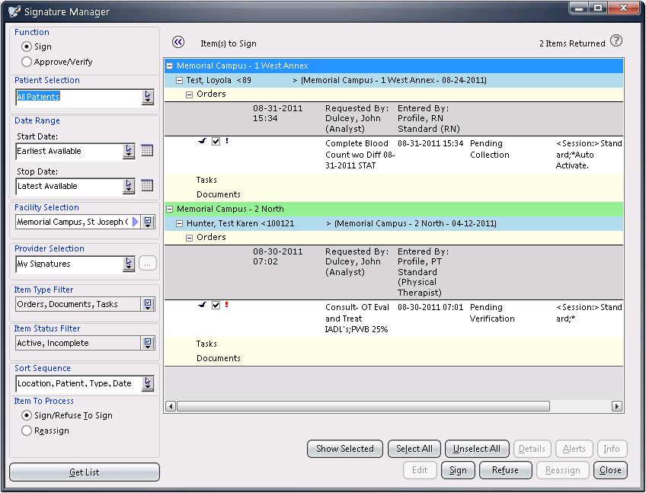
Filter Option | Description
Sign | When selected, displays all items requiring a signature.
Approve/Verify | When selected, displays all items requiring verification/approval.
Patient Selection
Select one of the following options:
- This Patient – All Charts: Display all items requiring signatures for the currently selected patient, regardless of the chart they belong to.

- This Patient – This Chart: Display items requiring signatures for the currently selected patient and the currently selected chart.

- This List – All Charts: Display items requiring signatures for patients on the current Patient List, no matter which chart contains the items.

- This List – This Chart: Display items requiring signatures for the patient visits on the current Patient List and the currently selected chart.

- All Patients: Display items requiring signature for any patient.
Start Date  Stop Date | The starting and ending dates for items to sign. You can use the calendar to select any other date. You can also select logical dates, such as Today, Yesterday, One Week Ago, One Month Ago, Earliest Available, and Latest Available.
Facility Selection | In a multi-facility enterprise, you can filter the list to items owned by one or more facilities. The default is All Facilities. If your enterprise has only one defined facility, this option is hidden.
Provider Selection | Specify the providers for whom to sign. You can select one of the following options, or click Selected Providers to open the Provider Selection window:  - My Signatures: Display items only if you are the person required to sign the items.  - My Group Signatures: Display items in the My Signatures group, and items that belong to others on whose behalf you can sign. If you have no signature groups assigned to you, only your signature items appear.  - Selected Providers: Display items for providers you select. If you have rights to all items (for example, Medical Records personnel), you can enter one or more provider names in the Selected Providers window, and find all items outstanding for those providers that meet the other filter criteria. If you can sign for others (you have been assigned one or more signature groups), you also have this option. The selected providers remain active in the filter criteria until the Provider Selection option is changed.  - All Providers: Display items that meet the other specified selection criteria. This option is available if you have appropriate rights, such as Medical Records personnel.
Item Type Filter | Select the type of items to display. You can select any combination of orders, tasks, and documents.
Item Status Filter | Select the status of the items to display. You can select Active or Refused.
Sort Sequence | Select how items are sorted in the list.
Item to Process | Select either Sign/Refuse to sign or Reassign.  Reassign is only available if you have rights to reassign signatures.
Get List | When a filter option is modified, click this button to update the item list to list all the items that match your selection criteria.

- Uncheck one or two of the orders (as you will use them in the next example for a different workflow). Note: Normally you would leave all orders checked.

- Click the Sign button at the bottom of the screen.

- Enter your password and click OK.

Notice all the orders you have signed present with a red checkmark icon next to them.

- Leave the Signature Manager window open for the next example.

Refuse to Sign Orders

Sometimes it is appropriate to refuse to sign an order. An example would be when a provider is indicated as having requested an order or order maintenance activity that they know they didn’t request. Sunrise Clinical Manager provides for this scenario through the Refuse Signature functionality.

Depending on your policies and workflow, the provider may refuse to sign orders and the medical records department or case manager may be tasked with following up to locate the provider who DID request the order. A report called
The Order Signature Report is available to help track and maintain these types of orders.

Once the requested by provider is known, the medical records representative may simply mark it as signed or reassign the order to the appropriate provider, who will then be notified with a red To Sign flag.

Scenario: There are remaining orders in your To Sign window. However you as the Attending provider did not request that order entered by Nurse Jackson.

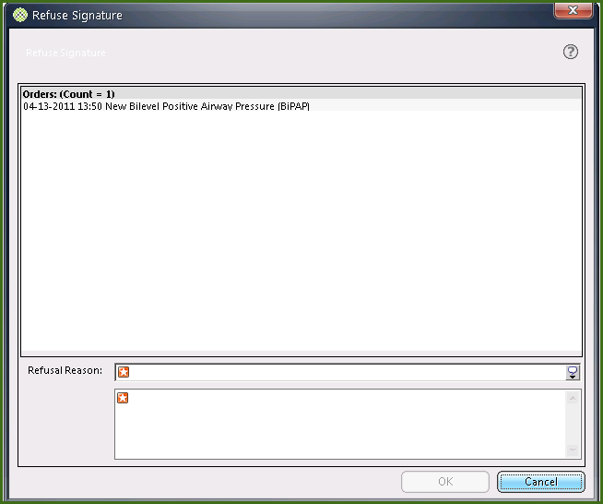

- Check the order that was not signed in the previous example.

- Click the Refuse button at the bottom of the screen. The Refuse Signature window displays with the refused items selected.

- From the Refusal Reason drop-down list, select Incorrect Physician Selected.

- Click OK.

- Close the Signature Manager window.

Business Rules for To Sign and To Verify

Several business rules are in place for order signature and verification.

- If orders are first verified, they are also signed.

- If orders are first signed, a second action must be taken to verify them.

- Orders for multiple patients can be signed at once by selecting more than 1 patient in the Signature Manager and clicking the Sign button 1 time to sign them all.

- Multiple patients’ orders cannot be verified at once. While multiple patients’ order can be seen in the Signature Manager that need to be verified, you must choose 1 patient > click Approve/Verify > then choose the next patient.

Toolbar Buttons Related to Order Entry Functions

You may find the following toolbar buttons beneficial for order entry related functions in SCM.

Icon | Name | Description
   | Enter Orders | The icon above opens a blank worksheet. The icon below indicates there are unsubmitted orders.
 | Enter Health Issue | Enter a new diagnosis or health issue for a patient.
 | Allergies Summary | View a list of the patient’s allergies and enter a new allergy for a patient.
 | Signature Manager | Sign and co-sign orders, tasks, and documents.
 | Rx Writer | Create, maintain, and print patient prescriptions in an outpatient setting.
 | Print Reports | Print or preview reports.
 | Drug Info | Accesses the Multum Drug database (only displays if Multum available).

Icons on the Orders Tab

Based on the type of order, the following icons may display next to an order on the Orders tab.

Icon | Description
 | Conditional order. The number of active activations that display after the condition text: <condition text> (Avail Activations = x) where x is the number of remaining activations. When the number of activations is unlimited, x = Unlimited.
 | View has been filtered.
Standard order set. This icon is only available in the Requested by or
Requested by Details views.
 | Order set with a multi-order form. Icon is only available in the Requested by or Requested by Details Views.
 | Linked order set. Icon is only available in the Requested by or Requested by Details view.
Linked order set with a multi-order form. Icon is only available in the
Requested by or Requested by Details view.
 | Parent order of order series.
 | Task has been documented at order entry.
 | Item has a warning message that can be viewed by clicking the icon.
 | History of Order Modification
 | Order series
 | Item cannot be ordered. Click the order item to find out why.
 | Discharge order
 | Hold order
   | Suspended order  Unsuspend order
 | Master repeat order. A status of “Active Master Order” is used to identify a Master repeat order. The status is updated to “Repeat Generation Finished” when all repeat occurrences have been generated. The status is updated to “Completed Master Order” when the last occurrence has been completed.
 | Repeat occurrence
 | STAT order
 | PRN order
 | Order has been modified and has a history. The icon displays when a user uses modify function to make a change to one of the fields on the order form for any order that is not on hold or pending verify (does not include pending Rx verify).
 | History of Order Modification
 | Order has not been verified by the pharmacy
 | Review Status
 | Alert on an order
 | Document in progress
 | Urgency Status
 | Incomplete document attached to an order
 | Health issue associated with an order.
 | Complete document attached to an order
 | A review on the order is required
 | Order Message
 | A review on the order is overdue
 | Release Order
 | Order is pending verification of a maintenance action (that is, suspend or discontinue). The icon displays with a description such as: “A <maintenance action> request is pending verification”.

